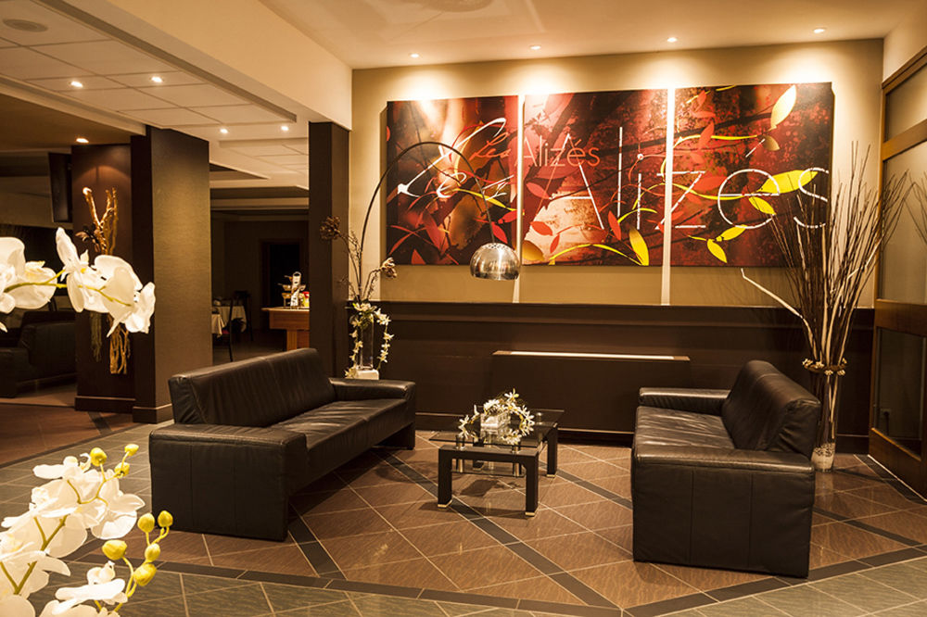
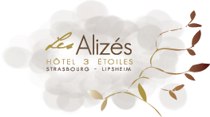

The charm and the Alsatian hospitality for your seminars…

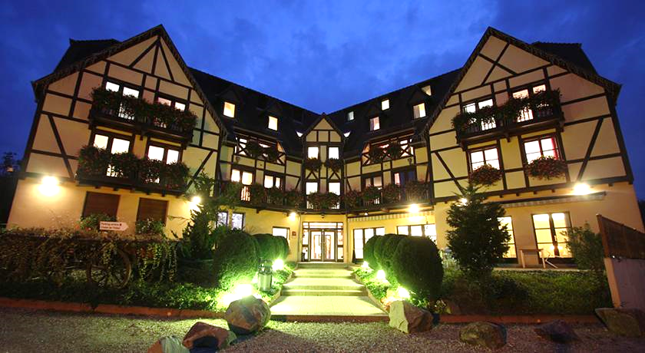

Located in a small Alsatian village in Lipsheim,
on the edge of the forest, the Hotel is nevertheless
very close to Strasbourg only 13 km.

In addition to our seminar rooms, the hotel also offers
a wellness area and 2 restaurants for your pleasure
in a mix of modern and Alsatian styles.

The various seminar Options:

½ Study Day
Price per Person
- The meeting room / 1 break
- Lunch with starter, main course and dessert (1/4 wine, mineral, 1 coffee)
Tradition at the Restaurant « A l ’Ange » : 48 €
Gourmet in the restaurant « Chalet de l’Hôtel » : 64 €

Study Day
Price per Person
- The meeting room / 2 breaks
- Lunch with starter, main course and dessert (1/4 wine, mineral, 1 coffee)
Tradition at the Restaurant « A l ’Ange » : 54 €
Gourmet in the restaurant « Chalet de l’Hôtel »: 69 €

Meeting room Rental only

- Day : 250 €
- ½ Day (Morning rental from 8:00 to 12:00 or afternoon from 14:00 to 18:00) : 125 €
- ½ Day (Rent beyond 7pm) : 136 €
- Welcome coffee: Price per Person : 4,00 €

For more information on our services "Residential Package" ½ board or Full, you can contact us at the contacts you find here below ;

Seminar room

Facilities adapted to professional events…

The hotel offers three seminar rooms whose occupancy is up to 100 people,
With all digital or manual modern equipment for a successful day:

- Board + felt pen
- Video projector
- Microphone
- Flat screen TV

Room | Area | U-shaped | Theatre-shaped | Classroom-shaped
001 | 98m² | 46 pers | 110 pers | 42 pers
002 | 54m² | 28 pers | 50 pers | 20 pers
003 | 45m² | 18 pers | 40 pers | 18 pers
 | 90m² | 36 pers | 60 pers | 25 pers
Also includes Free Wi-Fi and Heating / Air Conditioning

Hotel les Alizés

A peaceful place, conducive to concentration and reflection…

During your stay, you will be accommodated in the 53 comfortable rooms,
Overlooking the village or forest, including 2 Deluxe Rooms, 2 Suites &
4 Rooms accessible for disabled guests.

The rooms have :

- Private Bath room
- Safe
- Flat screen room
- Telephone direct line
- Free Wi-fi

The Restaurants

For the organization of seminars and workshops, the Hotel proposes two meeting Packages in order to satisfy all the expectations:

Our Option are the following:

« Tradition » or « Gourmet »

- The Restaurant "A l ‘Ange" located 300 meters from the Hotel, is a traditional Alsatian restaurant.
The Restaurant welcomes you from Monday to Friday Midday and Evening as well as Saturday evening.

- The Restaurant "Le Chalet de l'Hôtel" located behind the Hotel on the edge of the forest, is a gourmet restaurant.
The Restaurant welcomes You Monday noon, Tuesday, Thursday and Friday lunch and dinner as well as Saturday evening and Sunday lunch.
We inform you that the latter is closed on Monday evening in autumn and winter except for the month of December.

Whether half-day or study day, residential packages with half board or full board, they are all modular according to the type of restoration chosen.

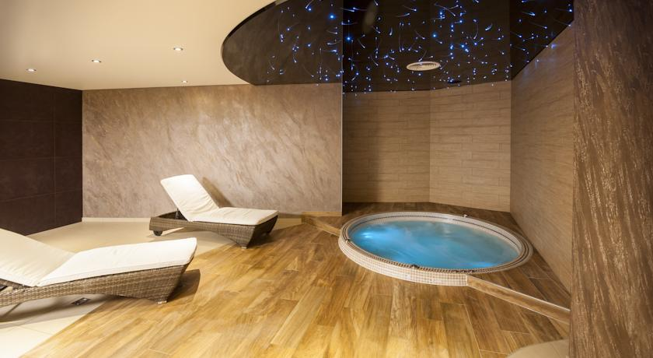
The wellness area

The Wellness area nestled in the greenery

The hotel offers a beautiful wellness area with :

- Indoor Swimming pool
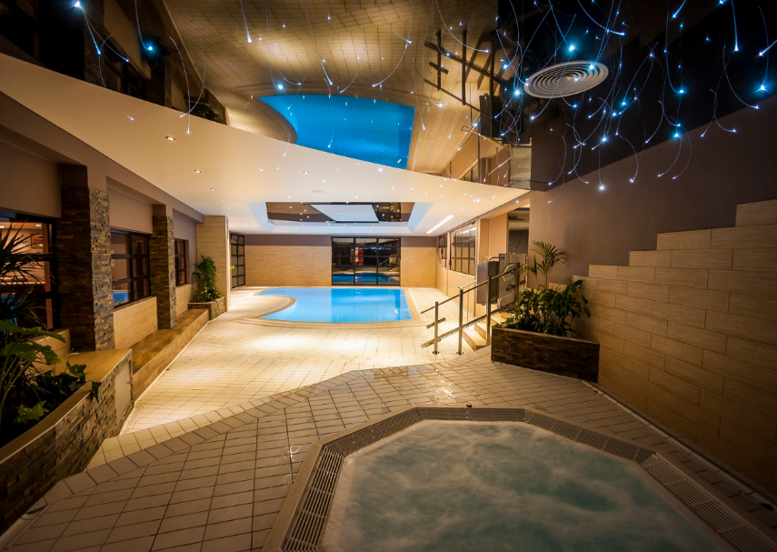
- Sauna Traditional or aromatic
- Hammam
- 2 Jacuzzis
- Laconium

Well-being and relaxation are waiting for you!

